Question 1


Source port #: U

Destination port #: V

Source port #: W

Destination port #: X

Source port #: Y

Destination port #: Z

Figure 2
Figure 2 shows two hosts running processes P1, P2, and P3 (as described by Figure 2) and are communicating to the server running a HTTP service.

a. Assume that connectionless-demultiplexing is used. Describe how the processes P1, P2 and P3 can send data to the HTTP application running at the server.
- A socket with port number 80 (http) is created at the server.
- Each processes will send data to the same port number (port 80).

b. Assume that a connection oriented demultiplexing is used. Describe how the processes P1, P2 and P3 communicates with the server on the HTTP service.
- Each process have their own socket connection at the server.
- Each socket connection is identified using the source IP address, destination IP address, source port number and destination port number.
- All processes send to their own dedicated socket connection.

c. Fill in the values of U, V, W , X, Y and Z for the following port numbers of processes P1, P2 and P3. P1: 11798, P2: 25692, P3: 45901
- U = 11798
- V=80
- W=45901
- X=80
- Y=25692
- Z=80
Question 2
Source port #
10981
Application Data (Payload)
X
Dest port #
53
Length
16
Figure 3

Figure 3 shows the contents of a Universal Datagram Protocol (UDP) header carrying a payload.

a. Calculate the value of X. Show your workings.

b. Suppose that the UDP packet was corrupted during transmission, such that the destination port number is changed from 53 to 61. Show in your working that the received UDP packet was corrupted.
Source port #: 0010 1010 1110 0101
Destination port #: 0000 0000 0011 1101
Length: 0000 0000 0001 0000

Question 3
Answer the questions about congestion control based on the parameters below.
Description | Parameters
TCP TYPE | TCP TAHOE
SSTHRESH | 8
3 DUPLICATE ACK | TR (Transmission Round) 10
TIMEOUT | TR (Transmission Round) 15
LAST TRANSMISSION ROUND | TR (Transmission Round) 20

a. Draw the graph for congestion window (in segments) versus transmission round.
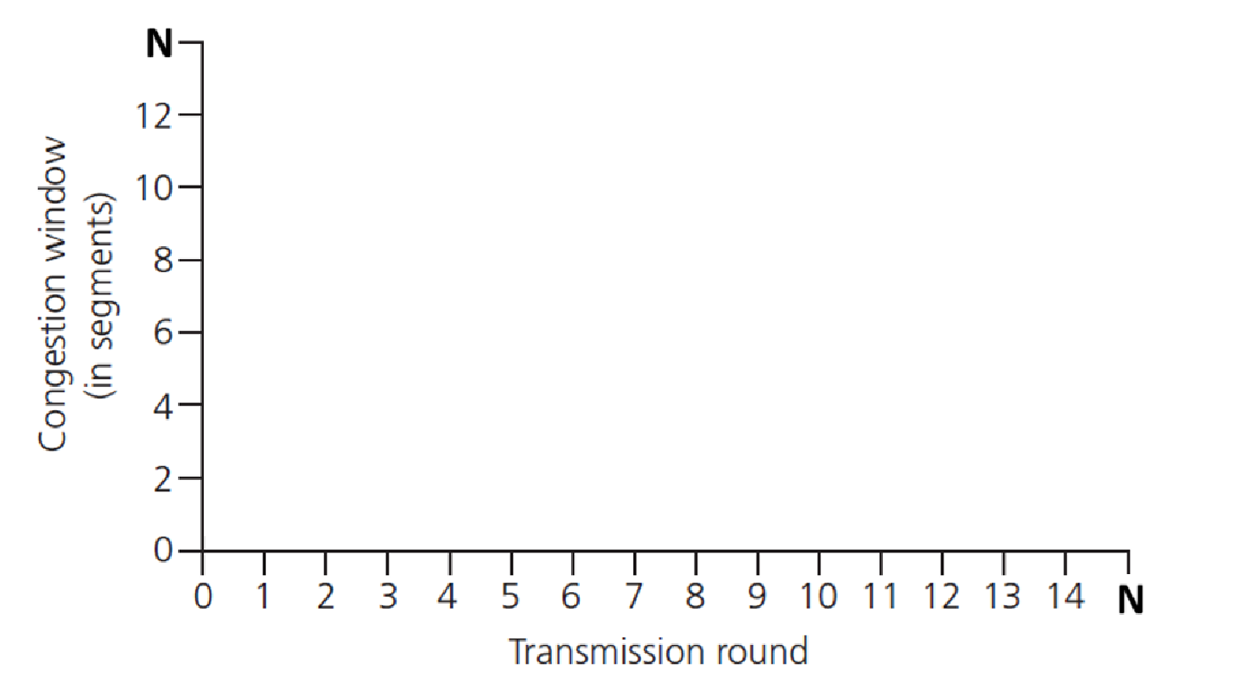

b. What is the total segment send?

c. Identify which transmission round is slow start (exponential).

d. Identify which transmission round is congestion avoidance (linear).

Question 4
Answer the questions about congestion control based on the parameters below.
Description | Parameters
TCP TYPE | TCP RENO
SSTHRESH | 8
3 DUPLICATE ACK | TR (Transmission Round) 10
TIMEOUT | TR (Transmission Round) 13
LAST TRANSMISSION ROUND | TR (Transmission Round) 20

a. Draw the graph for congestion window (in segments) versus transmission round.

b. What is the total segment send?
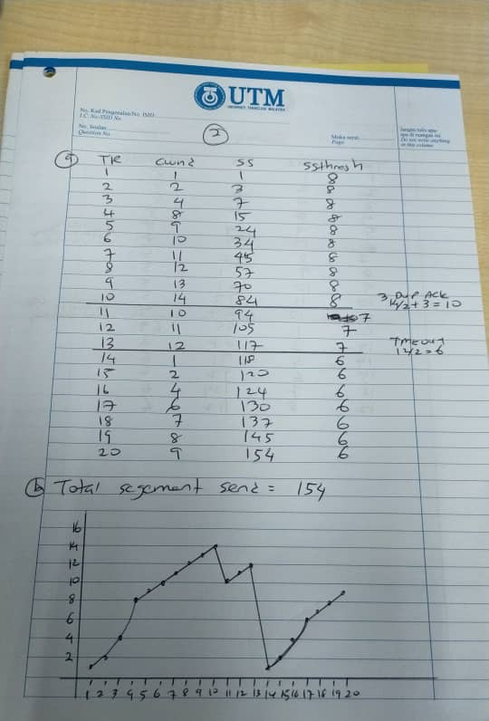
c. Identify which transmission round is slow start (exponential).
1, 2, 3, 4, 14, 15, 16

d. Identify which transmission round is congestion avoidance (linear).
5, 6, 7, 8, 9, 10, 11, 12, 13, 17, 18, 19, 20

e. Compare the results between Question 3 and Question 4.
Question 5
Answer the questions about congestion control based on the parameters below.
Description | Parameters
TCP TYPE | TCP RENO
SSTHRESH | 8
3 DUPLICATE ACK | TR (Transmission Round) 7
TIMEOUT | TR (Transmission Round) 13
LAST TRANSMISSION ROUND | TR (Transmission Round) 20

a. Draw the graph for congestion window (in segments) versus transmission round.

b. What is the total segment send?

c. Identify which transmission round is slow start (exponential).

d. Identify which transmission round is congestion avoidance (linear).

Question 6

Consider Figure 1. Assuming TCP Reno is the protocol experiencing the behaviour shown below, answer the following questions. In all cases, you should provide a short discussion justifying your answer.
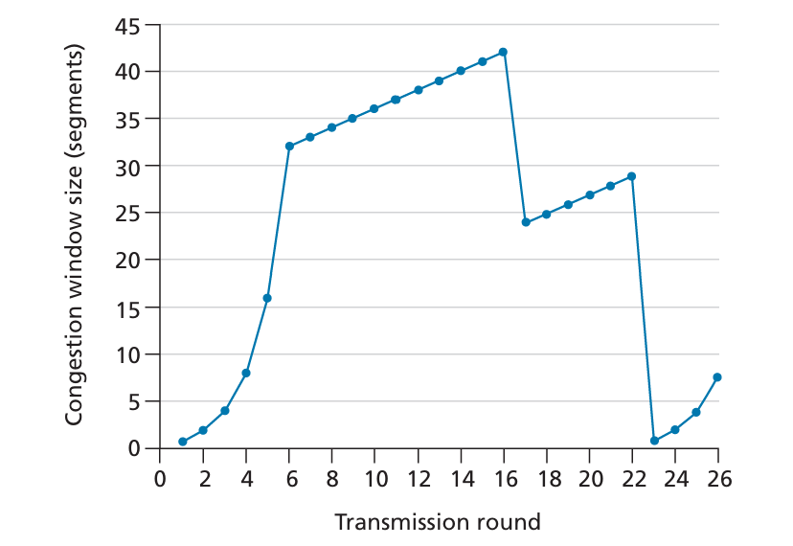
Figure 1: TCP window size as a function of time
a. Identify the intervals of time when TCP slow start is operating.
Ans: TR 1-6 and TR 23-26, as signified by the exponential increase in congestion window size in these intervals
b. Identify the intervals of time when TCP congestion avoidance is operating.
Ans: TR 6-16, as signified by the linear increase after TR 6
c. After the 16th transmission round, is segment loss detected by a triple duplicate ACK or by a timeout?
Ans: Triple duplicate is detected because the cwnd did not drop to 1, but it dropped to ssthresh + 3 = 24
d. After the 22nd transmission round, is segment loss detected by a triple duplicate ACK or by a timeout?
Ans: loss by timeout because TCP Reno only enters slow start in the event of loss due to timeout.
e. What is the initial value of ssthresh at the first transmission round?
Ans: ssthresh = 32
f. What is the value of ssthresh at the 18th transmission round?
Ans: ssthresh = 24 – 2 = 21
g. What is the value of ssthresh at the 24th transmission round?
Ans: ssthresh = roundup(29/2) = 15
h. During what transmission round is the 70th segment sent?
Ans:
TR = 7. This is because
At TR 6, total segment sent = 1+2+4+8+16+32 = 63
AT TR 7, total segment sent = 63 + 33 = 96. Segment 70 is included at TR7
i. Assuming a packet loss is detected after the 26th round by the receipt of a triple duplicate ACK, what will be the values of the congestion window size and of ssthresh?
Ans:
ssthresh = 8/2 = 4
cwnd = ssthresh+3 =4+3 = 7
j. Suppose TCP Tahoe is used (instead of TCP Reno), and assume that triple duplicate ACKs are received at the 16th round. What are the ssthresh and the congestion window size at the 19th round?
Ans: TCP Tahoe will go to slow start in all loss event. Therefore at the 19th round, ssthresh = 42/2 = 21, and cwnd = 4

Question 7

Sender
Receiver
Pkt 0
Ack 0
(R1)
Pkt 1
Pkt 2
Pkt 3
(R2)
(S1)
(S2)
Timeout
(R3)
(R4)
Figure 4

Figure 4 shows the sender sending four packets in a pipeline to the receiver. Packet 2 was lost during transmission
- Complete the time diagram for R1, R2 and S1, S2 when the Go-back-N protocol is used.

- What would happen to the packets sent by the sender in S1 and S2 once they are received by the receiver?

- Continue Figure 4 after timeout for Packet 2 have expired using Go-back-N protocol.

Question 8
Answer the questions based on Question 7 Figure 4.

